Review Worksheet ANSWERS – Disruptions to Homeostasis.

1: Draw a detailed flow diagram to show how thyroxine levels are regulated in a healthy person, including the effects of thyroxine on body tissues.

(12 marks)

*Should include:*

*Low levels of thyroxine (0.5) and/or falling metabolic rate (0.5) are detected by the hypothalamus (0.5)*

*Hypothalamus is stimulated (0.5) to produce Thyrotropin Releasing Factor (TRF)(0.5)*

*TRF travels in the blood vessels (0.5) of the infundibulum (0.5) to the Anterior Pituitary (0.5)*

*Anterior Pituitary is stimulated to produce Thyroid Stimulating Hormone (TSH) (0.5).*

*TSH is released and travels in the systemic circulation (0.5) to the Thyroid (0.5)*

*The thyroid is stimulated to produce Thyroxine (0.5)*

*Thyroxine is released from the thyroid and travels in the systemic circulation (0.5)*

*Thyroxine affects body tissues (0.5), which respond by increasing metabolic rate (0.5) and body temperature (0.5), increasing heart rate, blood pressure and respiratory rate (0.5) and increasing blood sugar (0.5) by stimulating the liver to convert glycogen to glucose (0.5).   
Rising levels (0.5) of thyroxine inhibit further production (0.5) of TRF (0.5) and TSH (0.5) so that thyroxine levels stabilise at homeostatic levels (0.5). This is negative feedback (0.5).*

*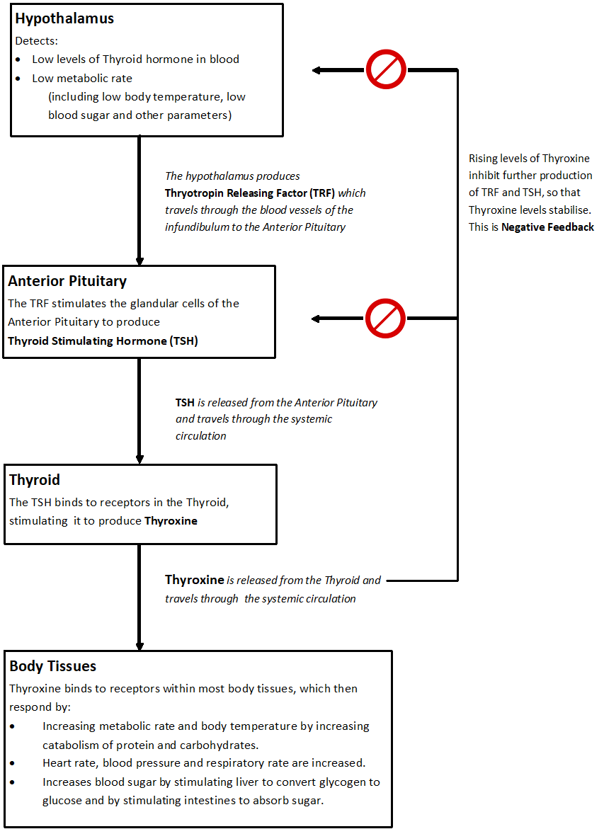*

2: Hyperthyroidism is a disorder where too much thyroid hormone is produced:

1. List symptoms of hyperthyroidism

(4 marks)

*Rapid heartbeat (0.5), weight loss (0.5), increased appetite (0.5), fatigue (0.5), sweating (0.5), anxiety (0.5), sometimes protruding eyeballs (0.5) and/or goitre (0.5).*

1. Using your understanding of temperature homeostasis, draw an annotated feedback loop to describe why someone with hyperthyroidism might sweat excessively.

(12 marks)

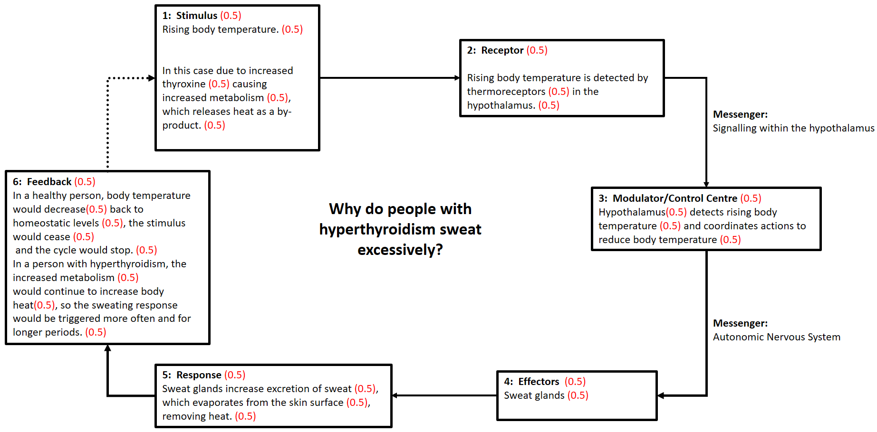

1. List and briefly describe some treatments for hyperthyroidism.

(4 marks)

* + *Drugs that block use of iodine (0.5) which is used by the body in making thyroxine (0.5)*
  + *Surgery to remove part or all of gland (0.5) so less thyroxine is produced (0.5).*
  + *Radioactive iodine therapy (0.5). Radioactive iodine is given (0.5) and is taken up by thyroid cells (0.5) which are then destroyed by the radiation (0.5), decreasing the amount of thyroxine produced (0.5)*

3: Hypothyroidism is a disorder where not enough thyroid hormone is produced.

1. Why might someone with hypothyroidism experience unexplained weight gain?

(3 marks)

*Because less thyroxine is being produced, Basal Metabolic Rate (BMR) (0.5) will fall (0.5), causing the cells to consume less glucose (0.5) and other nutrients via cellular respiration (0.5). The nutrients unable to be used for cellular respiration (0.5) are stored as fat (0.5), causing weight gain.(0.5)*

1. People with hypothyroidism have higher than normal levels of Thyroid Stimulating Hormone (TSH). Using your understanding of thyroid regulation, explain why this occurs.

(7 marks)

*People with hypothyroidism do not produce enough thyroxine (0.5), which results in lower metabolic rate (0.5) and lower body temperature (0.5). These stimulate the hypothalamus (0.5) to produce Thyrotropin Releasing Factor (TRF) (0.5), which in turn stimulates the Anterior Pituitary (0.5) to produce Thyroid Stimulating Hormone (TSH) (0.5). In a person with a normally functioning Thyroid, the thyroid would be stimulated to produce thyroxine (0.5), and the rising thyroxine levels (0.5) would have a negative feedback effect (0.5) on the production of TRF and TSH (0.5). If the thyroid is unable to produce thyroxine (0.5), as in people with hypothyroidism, then this negative feedback would not occur (0.5), causing TSH levels to rise higher than they would in a healthy person.(0.5)*

4: Emphysema is a disease that disrupts homeostasis by destroying alveoli in the lungs. Using your understandings of blood gas homeostasis, draw an annotated feedback loop to show why increased respiratory rate is a symptom of emphysema.

(12 marks)

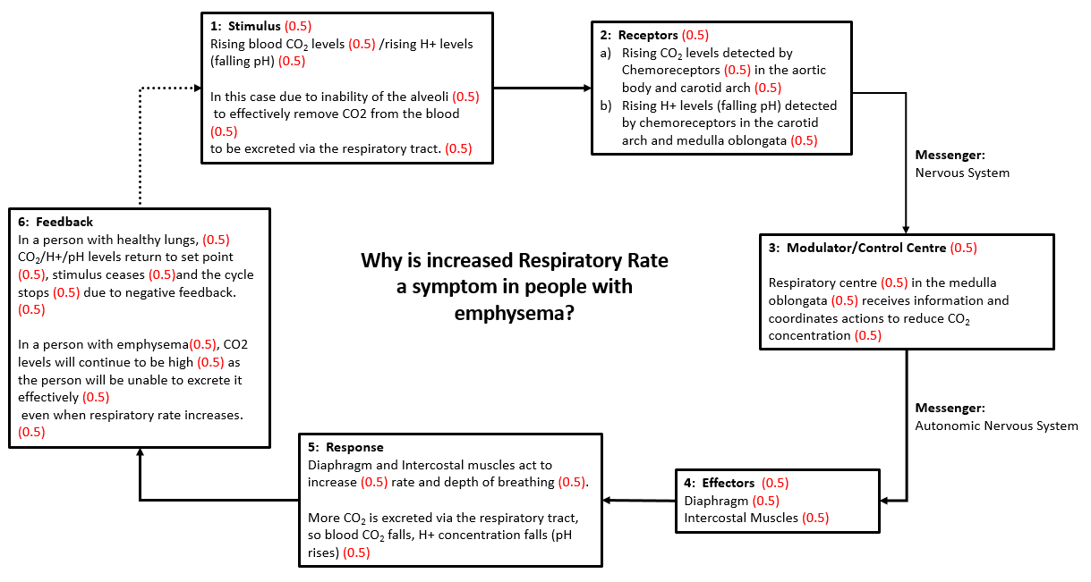

5: Draw a detailed flow diagram to show how growth hormone is regulated in a healthy person, and its effect on the body.

(10 marks)

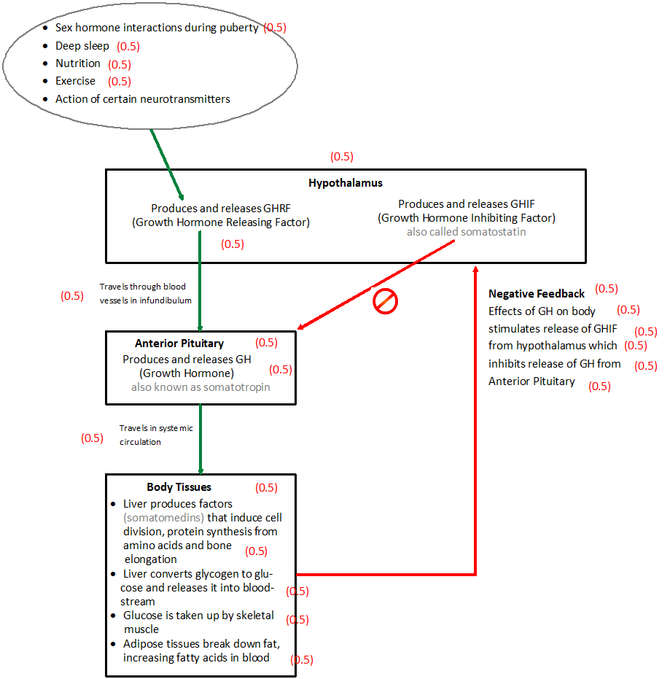

6: Describe in detail how recombinant DNA technology could be used to provide synthetic growth hormone to people with a growth hormone deficiency.

(8 marks)

*The gene that codes for human growth hormone is isolated from a healthy human cell. (0.5)*

*This happens using a restriction enzyme (0.5) that cuts at recognition sites (0.5) either side of the human growth hormone gene (0.5), separating the gene from the rest of the DNA strand (0.5). The restriction enzyme used produces staggered cuts with sticky ends (0.5) that match other strands that may be cut with the same restriction enzyme.*

*A plasmid is isolated from a bacterium (0.5), and cut using the same restriction enzyme (0.5) to produce matching staggered cuts and sticky ends (0.5). The plasmid DNA and the Human Growth Hormone gene are now placed together, matching the sticky ends (0.5).*

*The spliced DNA is then fused using DNA Ligase (0.5). The plasmid with the human growth hormone gene is a vector (0.5) that carries the gene into a new bacterium.*

*The plasmid containing the human growth hormone gene is then placed into a new bacterium (0.5). The bacterium will now reproduce, with each new bacterium containing a copy of the growth hormone gene. (0.5). The bacterial colony will then produce large amounts of growth hormone (0.5).   
  
The insulin produced by the bacteria is extracted (0.5) and refined (0.5), so that it can be used as a medication to treat Growth Hormone Deficiency. (0.5)*

7: Gene therapy is currently experimental and is not yet used to treat human disease.

1. Describe the process behind how gene therapy might work.

(2 marks)

* *Aims to treat or cure disease by identifying faulty genes and inserting healthy ones (0.5).*
* *The healthy gene of interest is inserted into a virus, using recombinant DNA technology (0.5).*
* *The virus is then used as a vector to enter human cells (0.5)*
* *The healthy gene is then incorporated into cellular DNA by the virus, replacing the faulty gene. (0.5)*

1. Describe the causes and symptoms of one disease that could be treated by gene therapy in the future:

(5 marks)

*Huntington’s Disease could be treated using gene therapy in future (0.5). It is caused by a single faulty gene (0.5), with dominant inheritance (0.5). The gene codes for an abnormal protein (0.5) which damages nerve cells in the brain (0.5). Onset of disease is usually after age 40 (0.5) and results in progressive (0.5) physical, cognitive and emotional changes (0.5), including the onset of dementia (0.5) and involuntary limb flailing (0.5). It is fatal. (0.5)*

8: Cell replacement therapy is currently experimental and is not yet used to treat human disease.

1. Describe the process behind how cell replacement therapy might work.

(2 marks)

* *Adult stem cells are isolated from the patient.(0.5)*
* *These are treated so that they differentiate into the required tissue (0.5), and cultured in the laboratory (0.5).*
* *The newly differentiated cells are inserted into the damaged areas (0.5) to regrow healthy tissue. (0.5)*

1. Name two diseases that could be treated using cell replacement therapy in future:

(2 marks)

*Alzheimer’s Disease (1), Parkinson’s Disease (1)*